Date: 22/10/2024
Roll No. and Name: 24ITC087 Khush Pithva
Course Code and Name: 2CS101 Computer Programming
Practical No: 7(a)
Aim: Consider a currency system in which there are notes of seven denominations, namely Rs. 1, Rs. 2, Rs. 5, Rs. 10, Rs. 20, Rs. 50 and Rs. 100. A sum of Rs. N is entered as an input. Write a function to compute the smallest number of notes that will combine to give Rs. N.
Methodology Followed:
#include<stdio.h>

void number(int n)
{
int rupee[9] = {500, 200, 100, 50, 20, 10, 5, 2, 1};
int rem = n, ans = n;
for (int i = 0; i < 9; i++)
{
ans = rem / rupee[i];
rem = rem % rupee[i];
if (ans != 0)
{
printf("\nNumber of %d notes is %d", rupee[i], ans);
}
}
}
int main()
{
long n;
printf("Enter your amount: ");
scanf("%ld", &n);
number(n);
}
Input/Output:
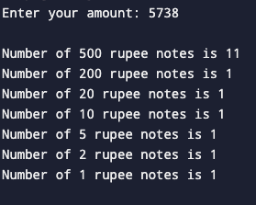
Theoretical Principle:
Use a greedy algorithm to minimize the number of currency notes by always choosing the largest possible denomination that does not exceed the remaining amount.

Practical No: 7(b)
Aim: Write a program to find F(n) such that F(n) = 0, if n = 0, F(n) = 1, if n = 1, otherwise F(n) = F(n - 1) + F(n - 2).
Methodology Followed:
#include<stdio.h>

int fofn(int n)
{
if (n == 0)
{
return 0;
}
else if (n == 1)
{
return 1;
}
else
{
return fofn(n - 1) + fofn(n - 2);
}
}
int main()
{
int n;
printf("Enter number : ");
scanf("%d",&n);
fofn(n);
printf("F(%d) = %d\n", n, fofn(n));

}
Input/Output:
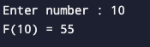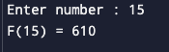
Theoretical Principle:
By complete this program we understood the knowledge of recursion in function.
Conclusion: here we learnt to use function and recursion.

